A576-A577-US-OH-Seneca County-Adena-Projectile Point-900-1100 CE

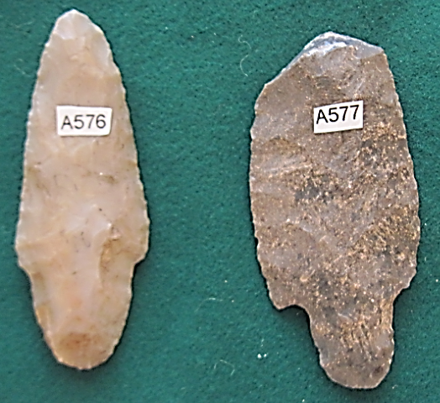

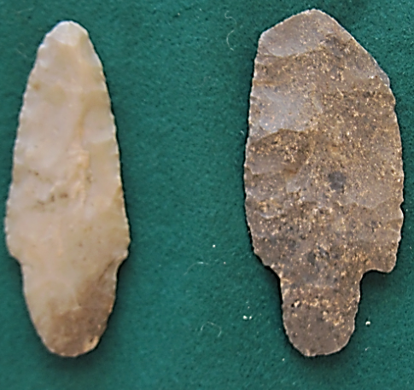

**Case no.: 11**

**Accession Numbers: A576-A577**

**Formal Label:**

**Display Description:**

Hopewell-Adena Points, 900-1100 CE

Documenting travel from Seneca County,

Ohio, by the Ohio River and the Damariscotta River,

To the Glidden midden, in Newcastle, Maine

The Adena projectile point from Ohio is thin (0.35 in, 8.93 mm), narrow (1.15 in, 29.22 mm), and slightly excurvate. It appears that it was originally more excurvate but this shape was straightened with secondary retouch serration. The point terminates in a rounded, broad stem.

This point was found in Seneca County, Ohio, on the banks of the Ohio River, not near any known Adena habitation, suggesting that the hunters who had used it were riverine people that used Ohio rivers as transport to distant hunting places. Adena points are found in the central Ohio Valley and along major tributaries of rivers in Ohio, Indiana, West Virginia, Kentucky, Alabama, Tennessee, Pennsylvania, New York and rarely in Maine, where the one on the right (A577) was found in a broken condition in the Glidden Shell Midden years ago. This find in Maine documents the furthermost eastern diffusion of the Adena people and their culture.

**LC Classification:**

**Date or Time Horizon:**

**Geographical Area:** Seneca County, Ohio, and the Glidden Shell Midden in Maine.

**Map:**

**GPS coordinates:**

**Cultural Affiliation:**

**Media:**

**Dimensions:** Ohio example is thin (0.35 in, 8.93 mm), narrow (1.15 in, 29.22 mm),

**Weight:**

**Condition: original**

**Provenance:**

**Discussion:**

The Adena culture was a Pre-Columbian First Nations culture that existed from 1000 to 200 BCE, in a time known as the Early Woodland period. “Adena,” originally named for its type site in Ohio, refers to what were probably a number of related societies sharing a burial complex and ceremonial system.

**References:**